Maintenance Service website

**ERD**

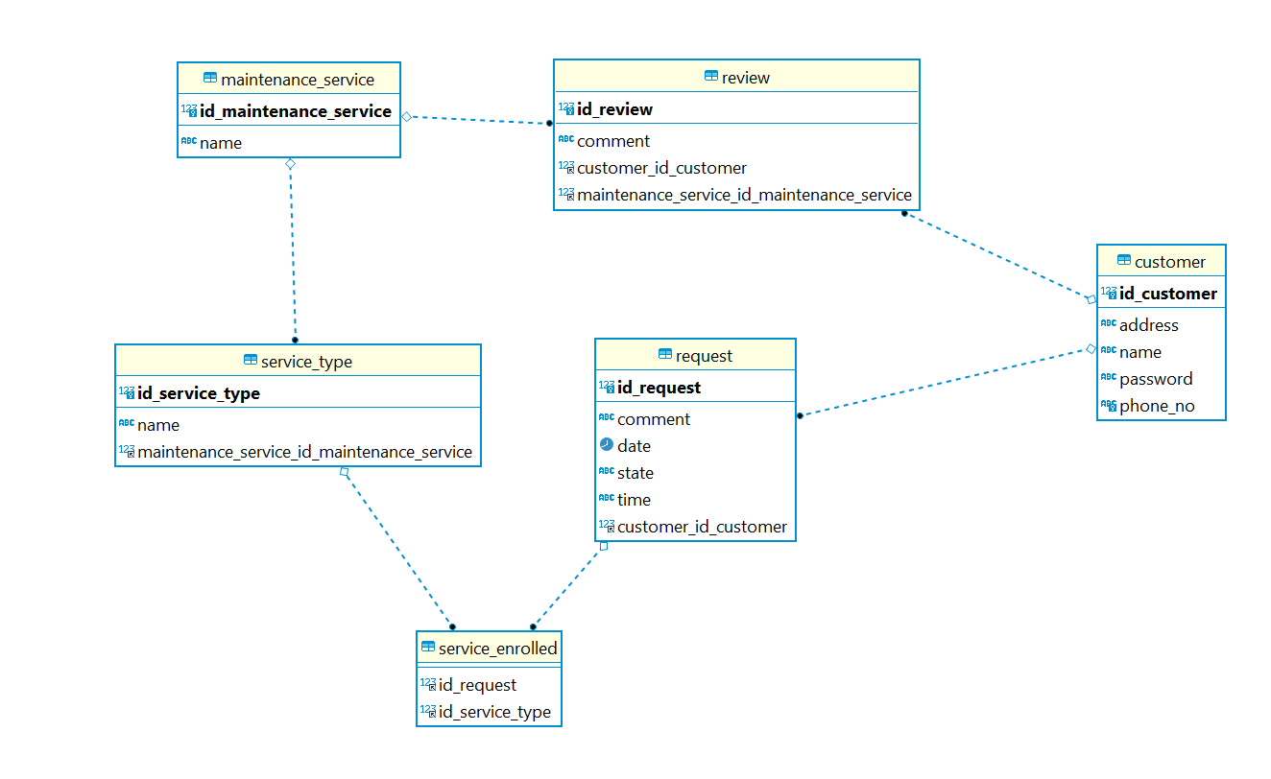

|  |  |
| --- | --- |
| Relationship | Tables |
| Many to Many | **Service type table** and **Request table** |
| Many to one | **Request table** and **Customer table** |
| Many to one | **Review table** and **Customer table** |
| Many to one | **Review table** and **Maintenance service table** |
| Many to one | **Maintenance service** **table** and **service type table** |

**Wire Frames**

Services page

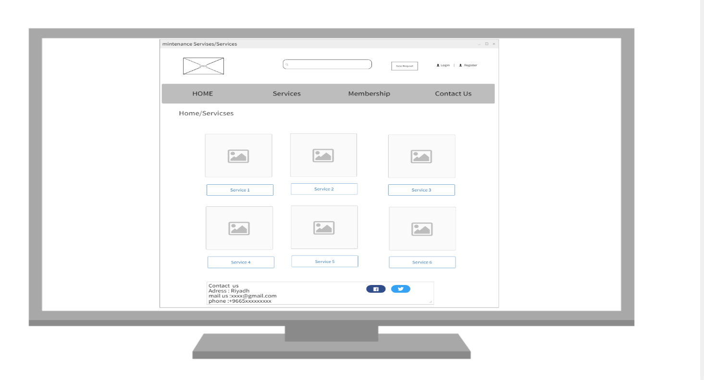

Service 1 page

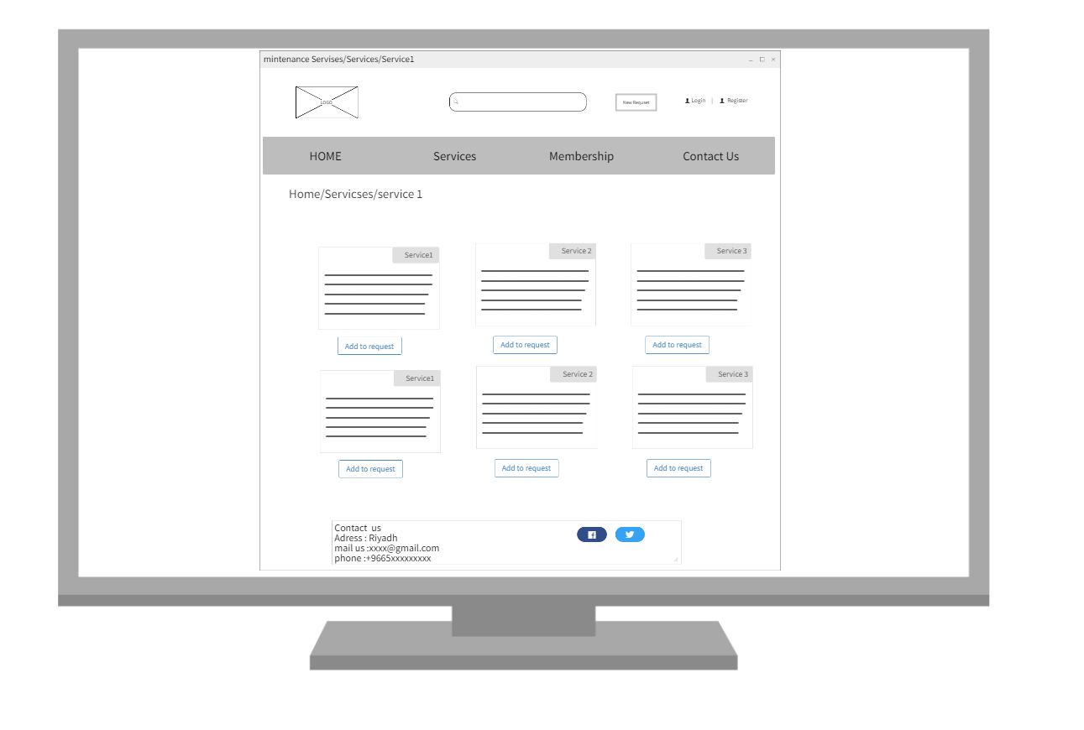

Request page

Register page

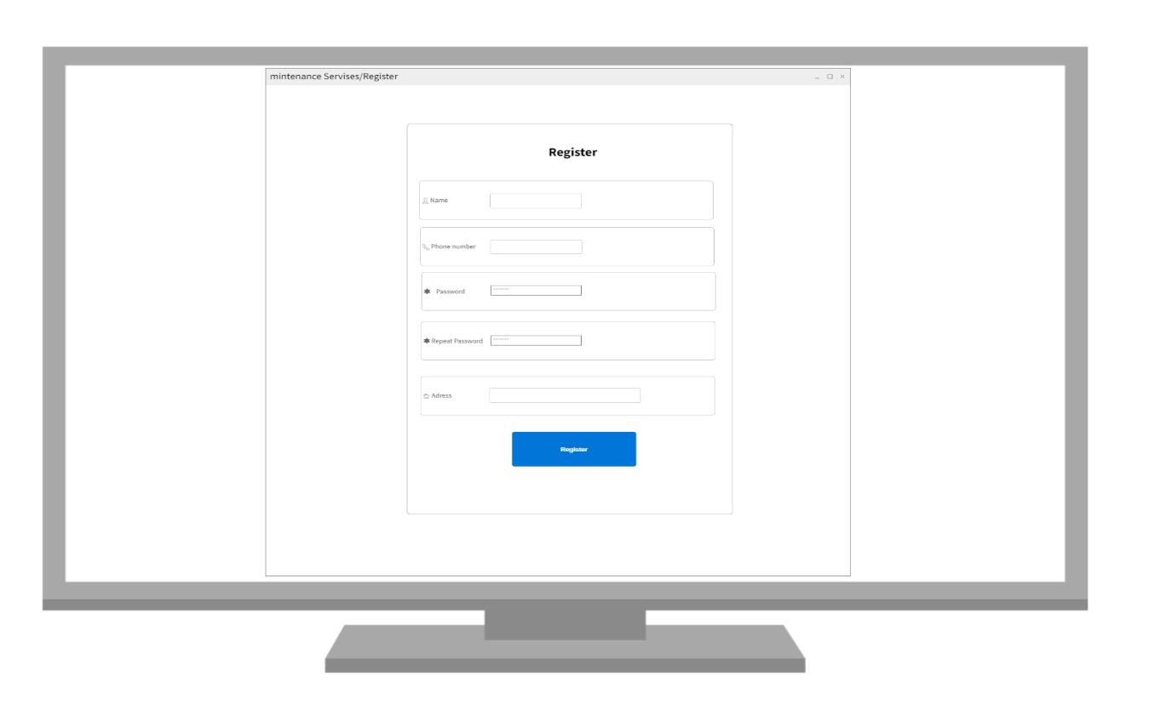

Login page

